***Topics covered***

* Agile methods
* Agile development techniques

***Rapid software development***

* Rapid development and delivery are now often the most important requirement for software systems
  + Businesses operate in a fast –changing requirement and it is practically impossible to produce a set of stable software requirements
  + Software has to evolve quickly to reflect changing business needs.
* Plan-driven development is essential for some types of system but does not meet these business needs.
* Agile development methods emerged in the late 1990s whose aim was to radically reduce the delivery time for working software systems

***Agile development***

* Program specification, design and implementation are inter-leaved
* The system is developed as a series of versions or increments with stakeholders involved in version specification and evaluation
* Frequent delivery of new versions for evaluation
* Extensive tool support (e.g., automated testing tools) used to support development.
* Minimal documentation – focus on working code

***Plan-driven and agile development***

3.2 PlanBasedAgile.eps

***Plan-driven and agile development***

***Plan-driven development***

* + A plan-driven approach to software engineering is based around separate development stages with the outputs to be produced at each of these stages planned in advance.
  + Not necessarily waterfall model – plan-driven, incremental development is possible
  + Iteration occurs within activities.

***Agile development***

* + Specification, design, implementation and testing are inter-leaved and the outputs from the development process are decided through a process of negotiation during the software development process.

***Agile methods***

* Dissatisfaction with the overheads involved in software design methods of the 1980s and 1990s led to the creation of agile methods. These methods:
  + Focus on the code rather than the design
  + Are based on an iterative approach to software development
  + Are intended to deliver working software quickly and evolve this quickly to meet changing requirements.
* The aim of agile methods is to reduce overheads in the software process (e.g., by limiting documentation) and to be able to respond quickly to changing requirements without excessive rework.

***Agile manifesto***

* *We are uncovering better ways of developing  software by doing it and helping others do it.  Through this work we have come to value:*
  + ***Individuals and interactions over processes and tools  
    Working software over comprehensive documentation   
    Customer collaboration over contract negotiation   
    Responding to change over following a plan***

***The principles of agile methods***

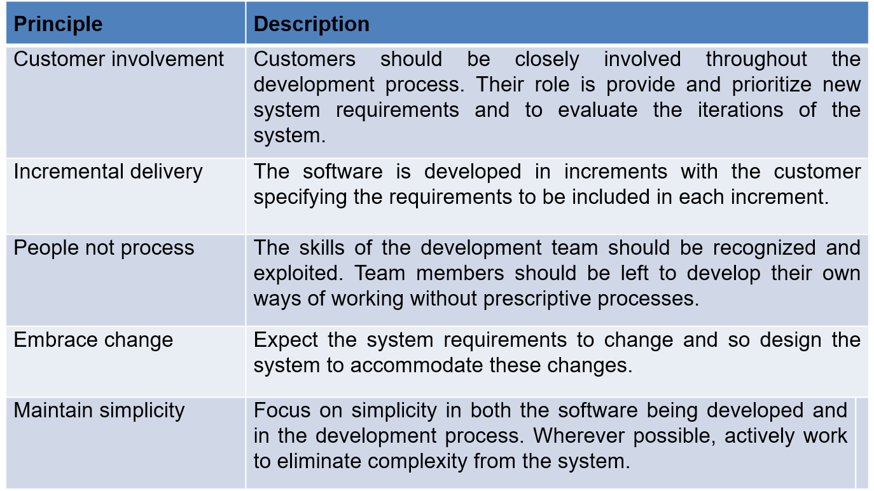

***Agile method applicability***

* Product development where a software company is developing a small or medium-sized product for sale.
  + Virtually all software products and apps are now developed using an agile approach
* Custom system development within an organization, where there is a clear commitment from the customer to become involved in the development process and where there are few external rules and regulations that affect the software.

***Agile Development Techniques***

***Extreme programming***

* A very influential agile method, developed in the late 1990s, that introduced a range of agile development techniques.
* Extreme Programming (XP) takes an ‘extreme’ approach to iterative development.
  + New versions may be built several times per day;
  + Increments are delivered to customers every 2 weeks;
  + All tests must run for every build and the build is only accepted if tests run successfully.

***The extreme programming release cycle***

3.3-XP-ReleaseCycle.eps

***Extreme programming practices (a)***

|  |  |
| --- | --- |
| **Principle or practice** | **Description** |
| Incremental planning | Requirements are recorded on story cards and the stories to be included in a release are determined by the time available and their relative priority. The developers break these stories into development ‘Tasks’. |
| Small releases | The minimal useful set of functionalities that provides business value is developed first. Releases of the system are frequent and incrementally add functionality to the first release. |
| Simple design | Enough design is carried out to meet the current requirements and no more. |
| Test-first development | An automated unit test framework is used to write tests for a new piece of functionality before that functionality itself is implemented. |
| Refactoring | All developers are expected to refactor the code continuously as soon as possible code improvements are found. This keeps the code simple and maintainable. |

***Extreme programming practices (b)***

|  |  |
| --- | --- |
| Pair programming | Developers work in pairs, checking each other’s work and providing the support to always do a good job. |
| Collective ownership | The pairs of developers work on all areas of the system, so that no islands of expertise develop and all the developers take responsibility for all of the code. Anyone can change anything. |
| Continuous integration | As soon as the work on a task is complete, it is integrated into the whole system. After any such integration, all the unit tests in the system must pass. |
| Sustainable pace | Large amounts of overtime are not considered acceptable as the net effect is often to reduce code quality and medium-term productivity |
| On-site customer | A representative of the end-user of the system (the customer) should be available full time for the use of the XP team. In an extreme programming process, the customer is a member of the development team and is responsible for bringing system requirements to the team for implementation. |

***XP and agile principles***

* Incremental development is supported through small, frequent system releases.
* Customer involvement means full-time customer engagement with the team.
* People not process through pair programming, collective ownership and a process that avoids long working hours.
* Change supported through regular system releases.
* Maintaining simplicity through constant refactoring of code.

***Influential XP practices***

* Extreme programming has a technical focus and is not easy to integrate with management practice in most organizations.
* Consequently, while agile development uses practices from XP, the method as originally defined is not widely used.
* Key practices
  + User stories for specification
  + Refactoring
  + Test-first development
  + Pair programming

***User stories for requirements***

* In XP, a customer or user is part of the XP team and is responsible for making decisions on requirements.
* User requirements are expressed as user stories or scenarios.
* These are written on cards and the development team break them down into implementation tasks. These tasks are the basis of schedule and cost estimates.
* The customer chooses the stories for inclusion in the next release based on their priorities and the schedule estimates.

***A ‘prescribing medication’ story***

3.5 StoryCard.eps

***Examples of task cards for prescribing medication***

3.6 TaskCards.eps

***Refactoring***

* Conventional wisdom in software engineering is to design for change. It is worth spending time and effort anticipating changes as this reduces costs later in the life cycle.
* XP however, maintains that this is not worthwhile as changes cannot be reliably anticipated.
* Rather, it proposes constant code improvement (refactoring) to make changes easier when they have to be implemented.
* Programming team look for possible software improvements and make these improvements even where there is no immediate need for them.
* This improves the understandability of software and reduces the need for documentation.
* Changes are easier to make because the code is well-structured and clear.
* However, some changes require architecture refactoring and this is much more expensive.

***Examples of refactoring***

* Re-organization of a class hierarchy to remove duplicate code.
* Tidying up and renaming attributes and methods to make them easier to understand.
* The replacement of inline code with calls to methods that have been included in a program library.

***Test-first development***

* Testing is central to XP and XP has developed an approach where the program is tested after every change has been made. **XP testing features:**
  + Test-first development.
  + Incremental test development from scenarios.
  + User involvement in test development and validation.
  + Automated test harnesses are used to run all component tests each time that a new release is built.

***Test-driven development***

* Writing tests before code clarifies the requirements to be implemented.
* Tests are written as programs rather than data so that they can be executed automatically. The test includes a check that it has executed correctly.
  + Usually relies on a testing framework such as Junit.
* All previous and new tests are run automatically when new functionality is added, thus checking that the new functionality has not introduced errors.

***Customer involvement***

* The role of the customer in the testing process is to help develop acceptance tests for the stories that are to be implemented in the next release of the system.
* The customer who is part of the team writes tests as development proceeds. All new code is therefore validated to ensure that it is what the customer needs.
* However, people adopting the customer role have limited time available and so cannot work full-time with the development team. They may feel that providing the requirements was enough of a contribution and so may be reluctant to get involved in the testing process.

***Test case description for dose checking***

3.7 DoseChecking.eps

***Test automation***

* **Test automation means** that tests are written as executable components before the task is implemented
  + These testing components should be stand-alone, should simulate the submission of input to be tested and should check that the result meets the output specification. An automated test framework **(e.g., Junit)** is a system that makes it easy to write executable tests and submit a set of tests for execution.
* **As testing is automated**, there is always a set of tests that can be quickly and easily executed
  + Whenever any functionality is added to the system, the tests can be run and problems that the new code has introduced can be caught immediately.

***Problems with test-first development***

* Programmers prefer programming to testing and sometimes they take short cuts when writing tests. **For example,** they may write incomplete tests that do not check for all possible exceptions that may occur.
* Some tests can be very difficult to write incrementally. **For example**, in a complex user interface, it is often difficult to write unit tests for the code that implements the ‘display logic’ and workflow between screens.
* It difficult to judge the completeness of a set of tests. Although you may have a lot of system tests, your test set may not provide complete coverage.

***Pair programming***

* Pair programming involves programmers working in pairs, developing code together.
* This helps develop common ownership of code and spreads knowledge across the team.
* It serves as an informal review process as each line of code is looked at by more than 1 person.
* It encourages refactoring as the whole team can benefit from improving the system code.
* In pair programming, programmers sit together at the same computer to develop the software.
* Pairs are created dynamically so that all team members work with each other during the development process.
* The sharing of knowledge that happens during pair programming is very important as it reduces the overall risks to a project when team members leave.
* Pair programming is not necessarily inefficient and there is some evidence that suggests that a pair working together is more efficient than 2 programmers working separately.